**Oracle 1z0-808**

**Java SE 8 Programmer I**

QUESTION NO: 2

Given the following segment of code :

Which two statements, if either were true, would make the code compile?

1. Vehicleis an interface that is implemented by theMotorcycleclass.
2. VehicleandMotorcycleboth implement theTransportationinterface
3. Vehicleis a superclass ofMotorcycle.
4. Motorcycleis a superclass ofVehicle.
5. VehicleandMotorcycleboth extend the Transportation superclass.
6. Motorcycleis an interface that implements theVehicleclass.

Answer: A C Explanation:

QUESTION NO: 76

Which one of the following code examples uses valid Java syntax?

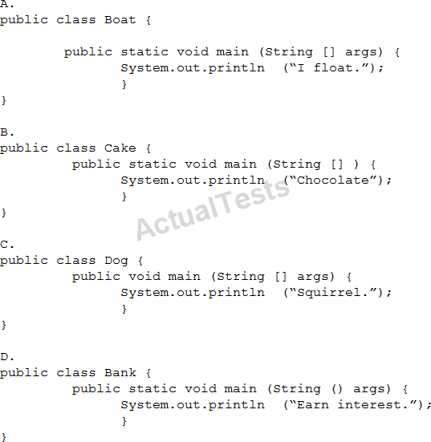

1. Option A
2. Option B
3. Option C
4. Option D

Answer: A

Reference:https://docs.oracle.com/javase/tutorial/getStarted/application/

QUESTIONNO: 79

Given the code fragment:

What is the result?

A. 1324

B. 2313

C. 3142

D. 4231

Answer: B not a valid question

QUESTION NO: 78

Given the code fragment:

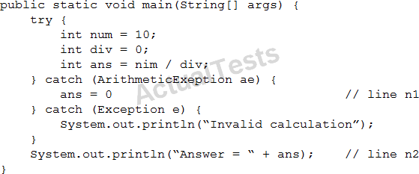

What is the result?

1. Answer = 0
2. Invalid calculation
3. Compilation fails only atline n1.
4. Compilation fails only atline n2.
5. Compilation fails only atline n1andline2.

Answer: E Explanation:

QUESTION NO: 79

Given: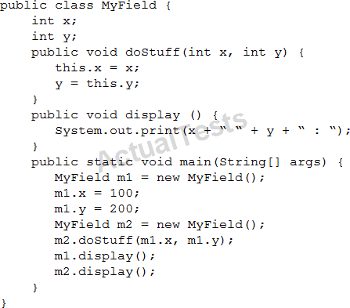

What is the result?

1. 100 0 : 100 200:
2. 100 0 : 100 0 :
3. 100 200 : 100 200 :
4. 100 200 : 100 0 :

Answer: D Explanation:

QUESTION NO: 80

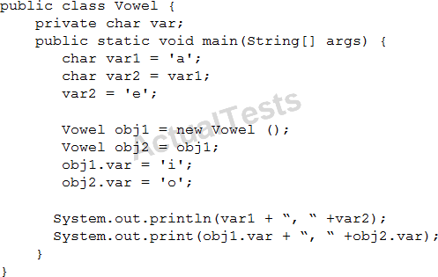Given:

1. a, e i, o
2. a, e o, o
3. e, e I, o
4. e, e o, o

Answer: B Explanation:

QUESTION NO: 81

Given the code fragment:

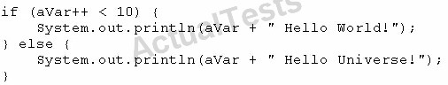

What is the result if the integer aVar is 9?

1. Compilation fails.
2. 10 Hello Universe!
3. 10 Hello World!
4. 9 Hello World!

Answer: C Explanation:

QUESTION NO: 82

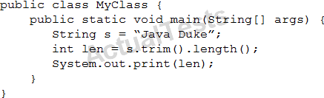Given:

What is the result?

1. Compilation fails.
2. 11
3. 8
4. 9
5. 10

Answer: D Explanation:

QUESTION NO: 83

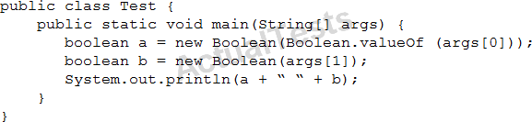Given:

And given the commands:

What is the result?

1. TRUE null
2. true false
3. false false
4. true true
5. AClassCastExceptionis thrown at runtime.

Answer: B Explanation:

true false

QUESTION NO: 84

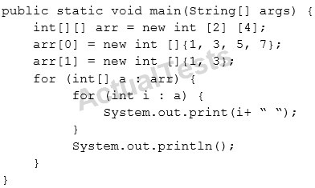Given the code fragment:

What is the result?

A. Compilation fails.

B.

C.

D.

E.

Answer: E Explanation:

QUESTION NO: 86

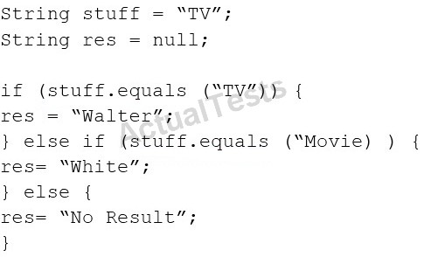Given:

Which code fragment can replace the if block?

A.

B.

C.

D.

Answer: B Explanation:

QUESTION NO: 88

Which statement is true about the switch statement?

1. It must contain the default section.
2. The break statement, at theend of each case block, is mandatory.
3. Its case label literals can be changed at runtime.
4. Its expression must evaluate to a single value.

Answer: D

[Reference:http://www.dummies.com/programming/java/switch-statements-in-java/](http://www.dummies.com/programming/java/switch-statements-in-java/)

QUESTION NO: 89

Given:

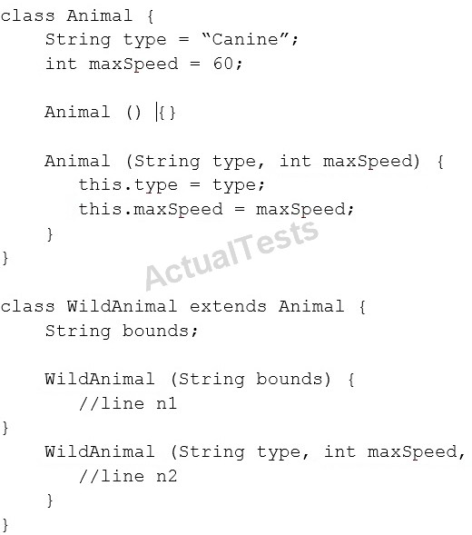

And given the code fragment:

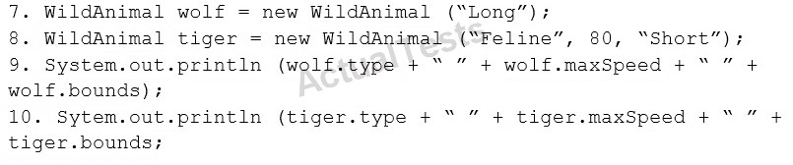

Which two modifications enable the code to print the following output? Canine 60 Long Feline 80 Short

1.  Replace line n1 with:
2. Replace line n1 with:
3. Replace line n2 with:
4. Replace line n1 with:
5. Replace line n2 with:



Answer: A,E Explanation:

QUESTION NO: 90

Given the code fragment:

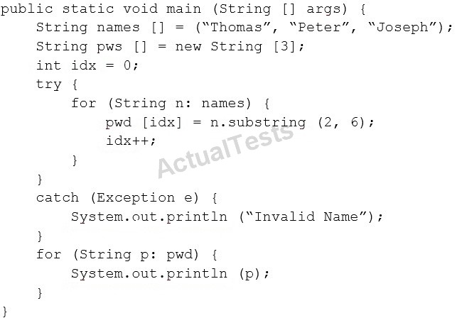

What is the result?

A. Invalid Name

B.

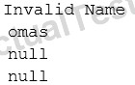C.

D.

Answer: C Explanation:

QUESTION NO: 91

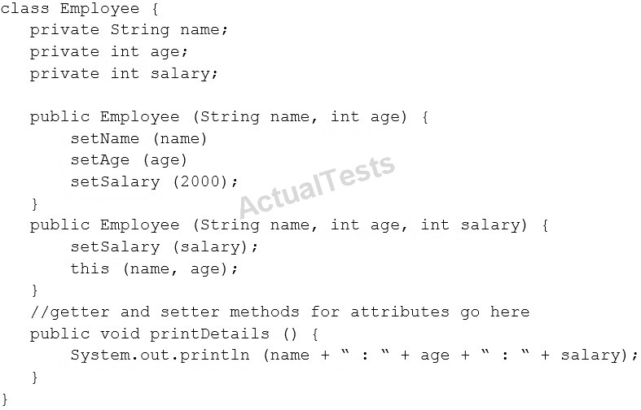Given the code fragment:

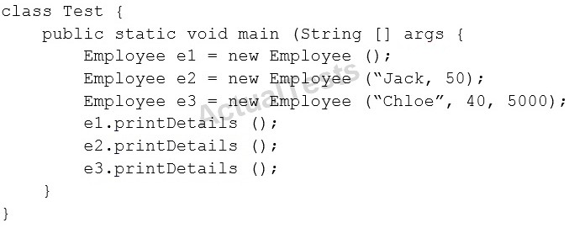Test.java

Which is the result?

1. Compilation fails in the Employee class.

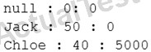

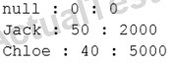C.

D. Compilation fails in the Test class.

E. Both the Employee class and the test class fail to compile.

Answer: E Explanation:

QUESTION NO: 92

Given the code fragments:

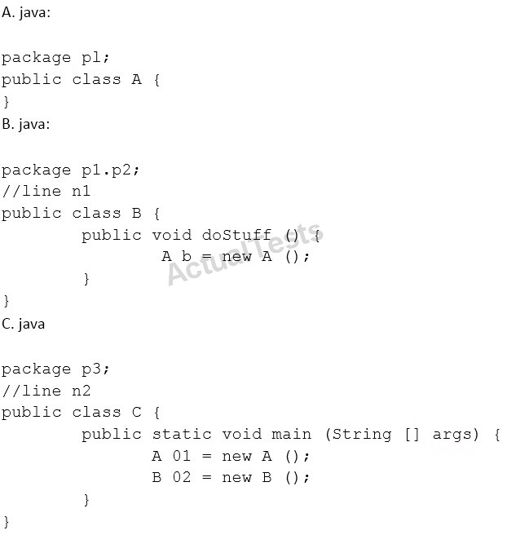

Which modification enables the code to compile?

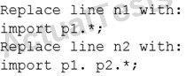A.

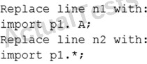B.

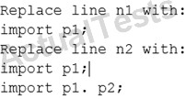C.

D.

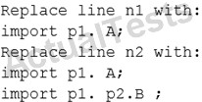

Answer: C Explanation:

QUESTION NO: 93

Given:

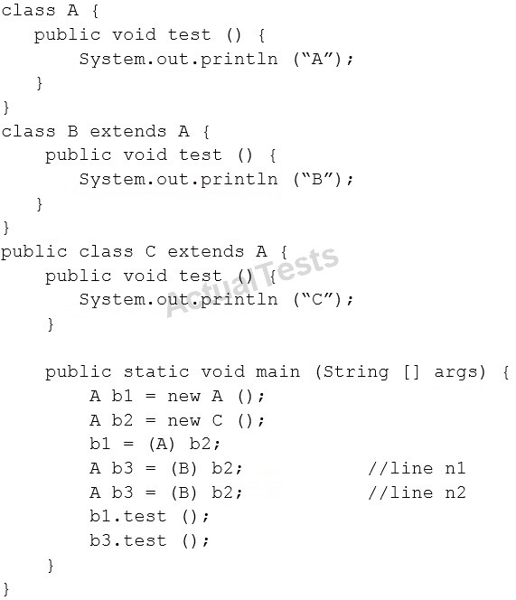

What is the result?

A. A B B. A C C. C C D. A ClassCastException is thrown only at line n1.

E. AClassCastException is thrown only at line n2.

Answer: B Explanation:

Correct Ans D

QUESTION NO: 96

You are asked to create a method that accepts an array of integers and returns the highest value from that array.

Given the code fragment:

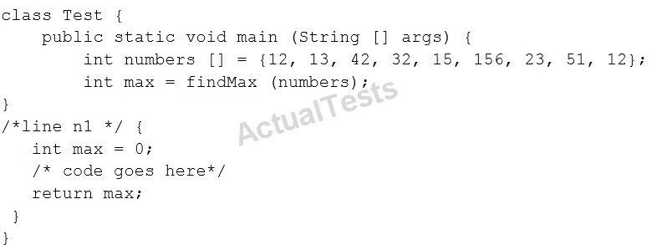

Which method signature do you use at line n1?

1. public int findMax (int [] numbers)
2. static int[] findMax (int max)

C.

static int findMax (int [] numbers)

D.

final int findMax (int [] )

Answer: A

Ans C

QUESTION NO: 97

Which three statements are true about the structure of a Java class?

A.

A public class must have a main method.

B.

A class can have only one private constructor.

C.

A method can have the same name as a field.

D.

A class can have overloaded static methods.

E.

The methods are mandatory componentsof a class.

F.

The fields need not be initialized before use.

Answer: A,C,E Explanation: Ans C D F

QUESTION NO: 98

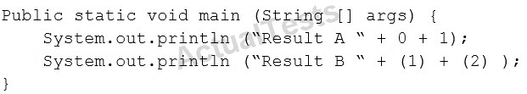Given the code fragment:

What is the result?

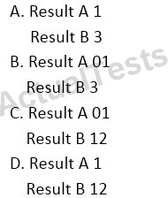

Answer: C Explanation:

QUESTION NO: 99

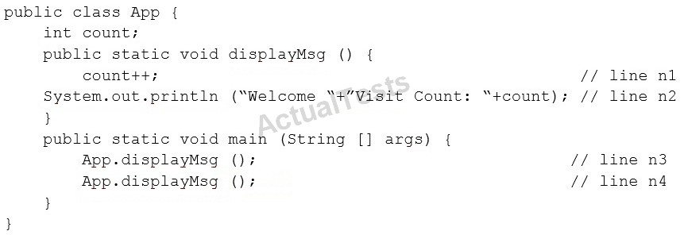Given:

What is the result?

A.

Compilation fails at line n3 and line n4.

B.

Compilation fails at line n1 and line n2.

C.

Welcome Visit Count:1 Welcome Visit Count: 2

D.

Welcome Visit Count:1 Welcome Visit Count: 2

Answer: B Explanation:

QUESTION NO: 102

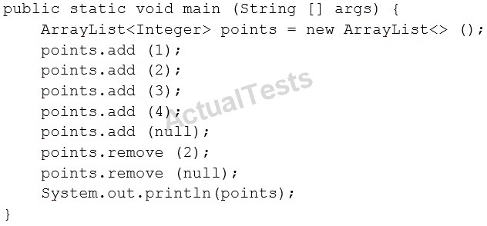Given the code fragment:

What is the result?

A.

A NullPointerException is thrown at runtime.

B.

[1, 2, 4]

C.

[1, 2, 4, null ]

D.

[1, 3, 4, null ]

E.

[1, 3, 4 ]

F.

Compilation fails.

Answer: F

Correct Ans B

QUESTION NO: 103

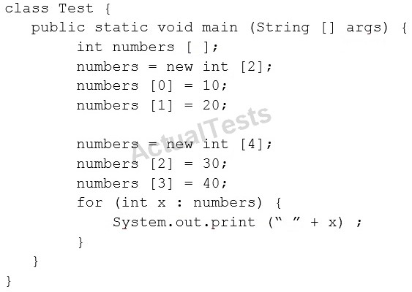Given:

What is the result?

A.

10 20 30 40

B.

0 0 30 40

C.

Compilation fails.

D.

An exception is thrown at runtime.

Answer: C

correc ans B

QUESTION NO: 105

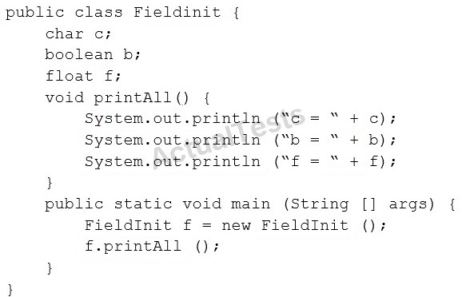Given:

What is the result?

A.

B.

C.

D.



Answer: C

Ans A

QUESTION NO: 106

Which three statements are true about exception handling?

A.

Only uncheckedexceptions can be rethrown.

B.

All subclasses of the RuntimeException class are recoverable.

C.

The parameter in a catch block is of Throwable type.

D.

All subclasses of the RuntimeException class must be caught or declared to be thrown.

E.

All subclassesof the Exception class except the RuntimeException class are checked exceptions.

F.

All subclasses of the Error class are checked exceptions and are recoverable.

Answer: C,E,F Explanation:

QUESTION NO: 107

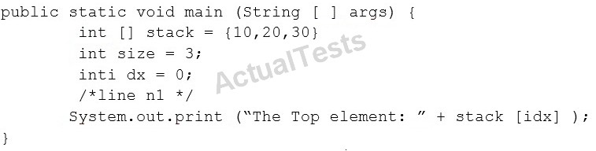Given the code fragment:

Which code fragment, inserted at line n1, pints The Top element: 30?

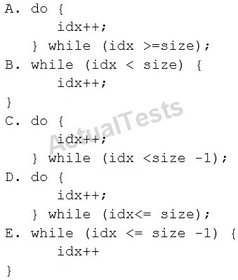

Answer: A Explanation:

Ans C

QUESTION NO: 108

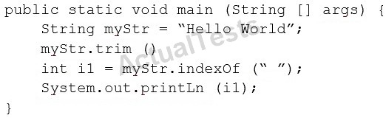Given the code fragment:

What is the result?

A. An exception is thrown at runtime. B. -1 C. 5 D. 0

Answer: A

Correct ans C

QUESTIONNO: 112

Given:

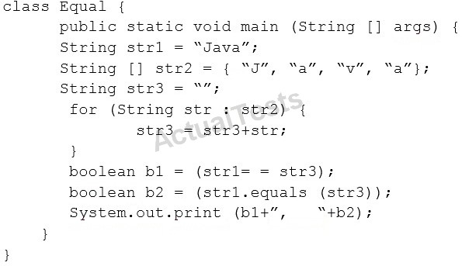

What is the result?

1. false, false
2. false, true
3. true, false
4. true, true

Answer: B

QUESTION NO: 109

Which two statements are true?

1. Error class is unextendable.
2. Error class is extendable.
3. Error is a RuntimeException.
4. Error is an Exception.
5. Error is a Throwable.

Answer: B,C

Ans B E

QUESTION NO: 110

Given the code fragment:

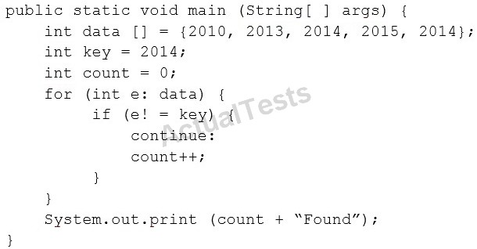

What is the result?

1. Compilation fails.
2. Found
3. Found
4. 3 Found

Answer: D

QUESTION NO: 111

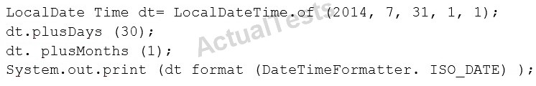Given the code

What is the result?

A.

An exception is thrown at runtime.

B.

07-31-2014

C.

2014-07-31

D.

2014-09-30

Answer: C

Ans A

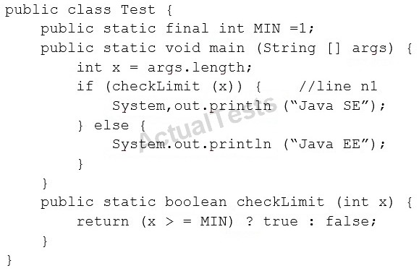

And given the commands:



What is the result?

A.

Java SE

B.

Java EE

C.

Compilation fails at line n1.

D.

ANullPointerException is thrown at runtime.

Answer: B Explanation:

QUESTION NO: 113

Given the following class:

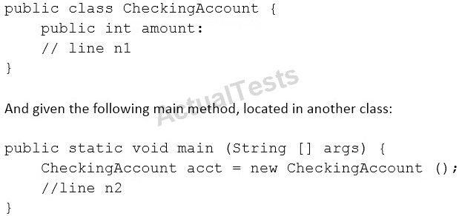

Which three pieces of code, when inserted independently, set the value of amount to 100?

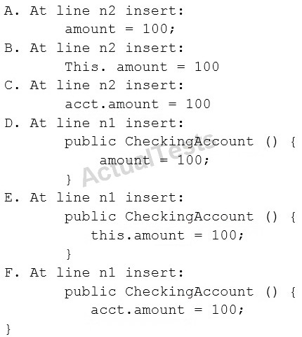

A.

Option A

B.

Option B

C.

Option C

D.

Option D

E.

Option E

F.

Option F

Answer: C,D,E Explanation:

QUESTION NO: 114

Given the code fragments:

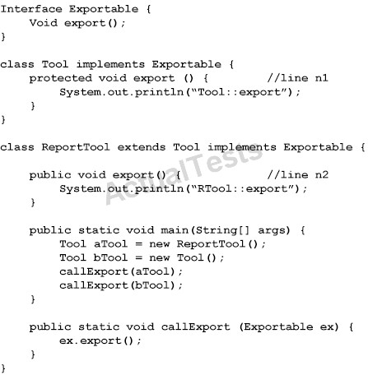

What is the result?

A.

Compilation fails only at line n2.

B.

RTool::export Tool::export

C.

Tool::export Tool:export

D.

Compilation fails only at line n1.

E.

Compilationfails at both line n1 and line n2.

Answer: E

QUESTION NO: 115

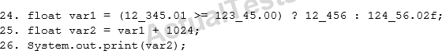

Given the code fragment:

What is the result?

A.

An exception is thrown at runtime.

B.

Compilation fails.

C.

13480.0

D.

13480.02

Answer: C Explanation:

QUESTION NO: 116

Given:

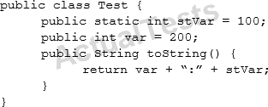

And given the code fragment:

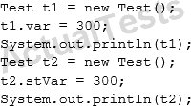

What is the result?

A.

300:300

200:300

B.

300:100

200:300

C.

300:0

0:300

D.

200:300

200:300

Answer: D

Ans B

QUESTION NO: 117

Given:

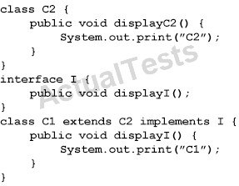

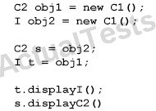And given the code fragment:

What is the result?

A.

C2C2

B.

C1C2

C.

C1C1

D.

Compilation fails

Answer: A

QUESTION NO: 118

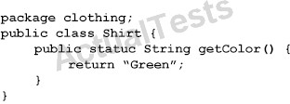

Given:

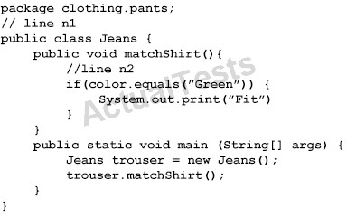

Ans D

Which two sets of actions, independently, enable the code fragment to print Fit?

A.

At line n1 insert:import clothing.Shirt;

At line n2 insert:String color = getColor();

B.

At line n1 insert:importclothing.*;

At line n2 insert:String color = Shirt.getColor();

C.

At line n1 insert:import static clothing.Shirt.getcolor; At line n2 insert:String color = getColor();

D.At line n1 no changes required.

At line n2 insert:String color = Shirt.getColor();

E.

At line n1 insert:import clothing;

At line n2 insert:String color = Shirt.getColor();

Answer: A

QUESTION NO: 120

Given the code fragment:

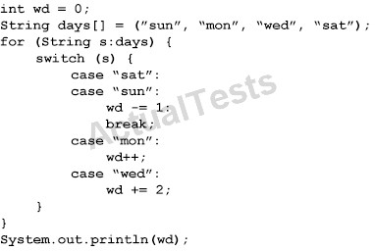

What is the result?

1. 3

B. 4

C.-1

D. Compilation fails.

Answer: B Explanation:

And D

if array uses curly braces then result will be 3, Ans A

QUESTION NO: 121

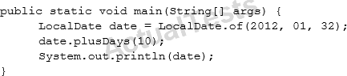Given the code fragment:

What is the result?

A.

2012-02-10

B.

2012-02-11

C.

Compilation fails

D.

A DateTimeException is thrown at runtime.

Answer: D Explanation:

java.time.DateTimeException: Invalid value for DayOfMonth (valid values 1 - 28/31): 32

QUESTION NO: 122

Given:

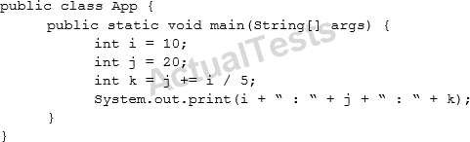

What is the result?

A.

10 : 30 : 6

B.

10 : 22 : 22

C.

10 : 22 : 20

D.

10 : 22 : 6

Answer: B Explanation: Explanation

QUESTION NO: 123

Given:

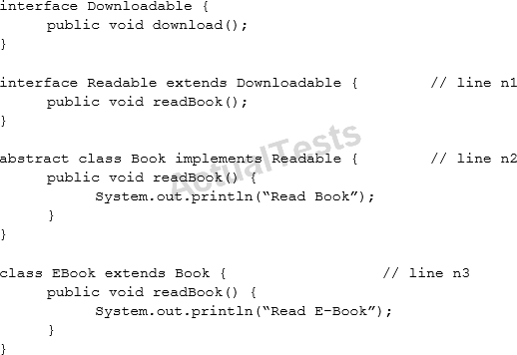

And given the code fragment:

What is the result?

1. Compilation fails at line n2.
2. Read Book
3. Read E-Book
4. Compilation fails at line n1.
5. Compilation fails at line n3.

Answer: B

Ans E

must have to override method download()

QUESTION NO: 124

Given the following class:

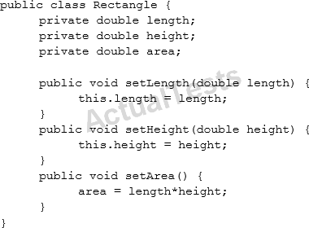

Which two changes would encapsulate this class and ensure that the area field is always equal to length * height whenever the Rectangle class is used?

A.

Call the setArea method at the end of the setHeight method.

B.

Call the setArea method at the beginning of the setHeight method.

C.

Call the setArea method at the end of the setLength method.

D.

Call the setArea method at the beginning of the setLength method.

E.

Change the setArea method to private.

F.

Change the area field to public.

Answer: A,E

Ans A C

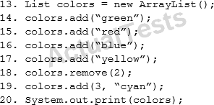QUESTION NO: 125

Given the code fragment:

What is the result?

A.

(green, red, yellow, cyan)

B.

(green, blue, yellow, cyan)

C.

(green, red, cyan, yellow)

D.

AnIndexOutOfBoundsExceptionis thrown at runtime.

Answer: C

Ans A

QUESTION NO: 126

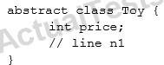Given the code fragment:

Which three code fragments are valid at line n1?

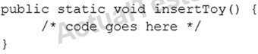A.

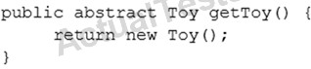B.

C.

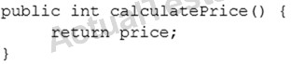D.

E.

Answer: C,D,E Explanation:

QUESTION NO: 127

Given:

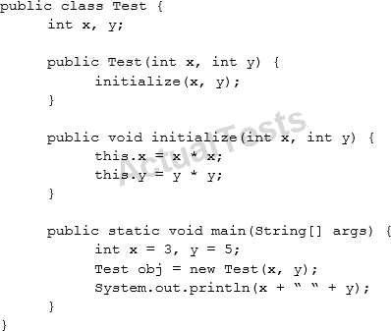

What is the result?

A.

Compilation fails.

B.

3 5

C.

0 0

D.

9 25

Answer: B Explanation:

QUESTION NO: 128

Given the code fragment:

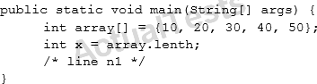

Which two code fragments can be independently inserted at line n1 to enable the code to print the elements of the array in reverse order?

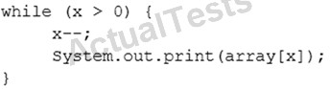A.

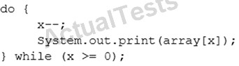B.

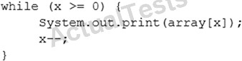C.

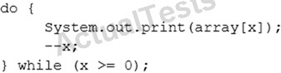D.

E.

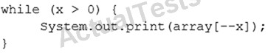

Answer: A,E Explanation:

QUESTION NO: 129

Given:

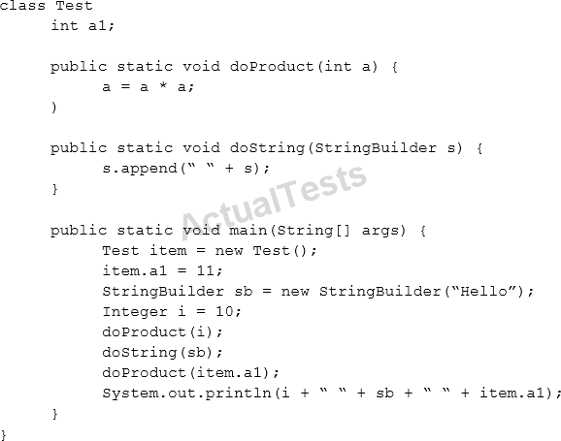

What is the result?

A.

10 Hello Hello 11

B.

10 Hello Hello 121

C.

100 Hello 121

D.

100 Hello Hello 121

E.

10 Hello 11

Answer: B Explanation:

Ans A

QUESTION NO: 130

Given the code fragment:

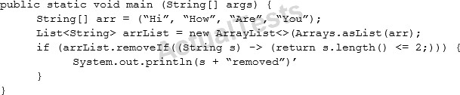

What is the result?

A.

Compilation fails.

B.

Hi removed

C.

An UnsupportedOperationException is thrown at runtime.

D.

The program compiles, but it prints nothing.

Answer: A Explanation:

QUESTION NO: 131

Which two class definitions fail to compile?

A.

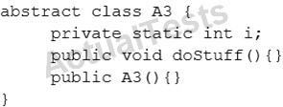

B.

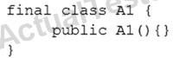

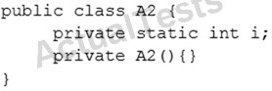C.

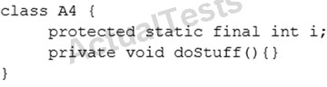D.

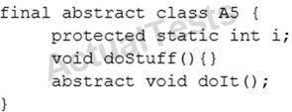E.

Answer: D,E Explanation:

QUESTION NO: 132

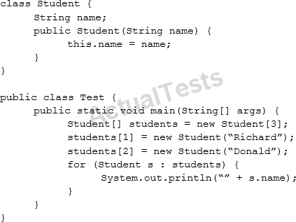Given:

What is the result?

A.

null Richard Donald

B.

Richard Donald

C.

Compilation fails.

D.

AnArrayIndexOutOfBoundsExceptionis thrown at runtime.

E.

ANullPointerExceptionis thrown at runtime.

Answer: A

Ans E

QUESTION NO: 133

The following grid shows the state of a 2D array:

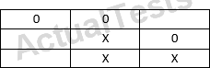

This grid is created with the following code:

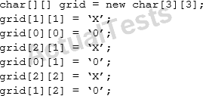

Which line of code, when inserted in place of //line n1, adds an X into the grid so that the grid contains three consecutive X’s?

A.

grid[1][3] = ‘X’;

B.

grid[3][1] = ‘X’;

C.

grid[0][2] = ‘X’;

D.

grid[2][0] = ‘X’;

E.

grid[1][2] = ‘X’;

Answer: C

Ans D

QUESTION NO: 134

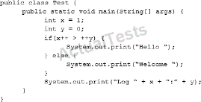Given:

What is the result?

A.

Hello Log 1:0

B.

Hello Log 2:1

C.

Welcome Log 2:1

D.

Welcome Log 1:0

Answer: C Explanation:

QUESTION NO: 135

Given the code snippet from a compiled Java source file:

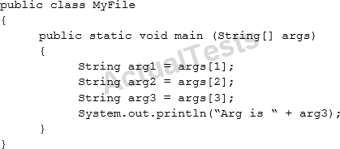

Which command-line arguments should you pass to the program to obtain the following output? Arg is 2

A.

java MyFile 1 3 2 2

B.

java MyFile 2 2 2

C.

java MyFile 1 2 2 3 4

D.

java MyFile 0 1 2 3

Answer: A Explanation:

QUESTION NO: 136

Given the code fragment:

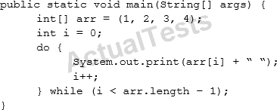

What is the result?

A.

1 2 3 4

followed by an ArrayIndexOutOfBoundsException

B.

1 2 3

C.

1 2 3 4

D.

Compilation fails.

Answer: A Explanation:

Ans D

Compilation fail in this line

int[] arr= (1, 2, 3, 4);

for using parenthesis while expection curly braces

QUESTION NO: 137

Given:

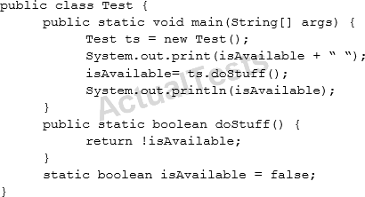

What is the result?

1. Compilation fails.
2. false true
3. true false
4. true true
5. false false

Answer: B Explanation: